Faculty of Computing


Compiler Construction Lab Tasks No # 09
Saira kousar -55503 BSCS ( Semester -6)

Task No # 01

LR(0) Parsing Table

Grammar:
S → A B
A → a A | b
B → c B | d

Solution:

Augmented Grammar

0: S' → S
1: S → A B
2: A → a A
3: A → b
4: B → c B
5: B → d

LR(0) item sets

State | Items
I₀ | S' → · S, S → · A B, A → · a A, A → · b
I₁ | S' → S·
I₂ | S → A · B, B → · c B, B → · d
I₃ | A → a · A, A → ·a A, A → · b
I₄ | A → b ·
I₅ | S → A B ·
I₆ | B → c · B, B → · c B, B → · d
I₇ | B → d ·
I₈ | A → a A ·
I₉ | B → c B ·

Action/Goto table

Terminals: a, b, c, d, $
Non-terminals: S, A, B

State | a | b | c | d | $ | S | A | B
0 | s3 | s4 |  |  |  | 1 | 2
1 |  |  |  |  | acc
2 |  |  | s6 | s7 |  |  |  | 5
3 | s3 | s4 |  |  |  |  | 8
4 | r3 | r3 | r3 | r3 | r3
5 | r1 | r1 | r1 | r1 | r1
6 |  |  | s6 | s7 |  |  |  | 9
7 | r5 | r5 | r5 | r5 | r5
8 | r2 | r2 | r2 | r2 | r2
9 | r4 | r4 | r4 | r4 | r4

Terms:
- sX → shift and go to state X
- rY → reduce using production Y
- acc → accept

Implement using C++ Code:

#include <iostream>
#include <stack>
#include <vector>
#include <map>
#include <string>
using namespace std;

int main() {
map<int, map<string, string>> action;

action[0]["a"] = "s3";
action[0]["b"] = "s4";
action[1]["$"] = "acc";
action[2]["c"] = "s6";
action[2]["d"] = "s7";
action[3]["a"] = "s3";
action[3]["b"] = "s4";
action[4]["a"] = "r3";
action[4]["b"] = "r3";
action[4]["c"] = "r3";

action[4]["d"] = "r3";
action[4]["$"] = "r3";
action[5]["a"] = "r1";
action[5]["b"] = "r1";
action[5]["c"] = "r1";
action[5]["d"] = "r1";
action[5]["$"] = "r1";
action[6]["c"] = "s6";
action[6]["d"] = "s7";
action[7]["a"] = "r5";
action[7]["b"] = "r5";
action[7]["c"] = "r5";
action[7]["d"] = "r5";
action[7]["$"] = "r5";
action[8]["a"] = "r2";
action[8]["b"] = "r2";
action[8]["c"] = "r2";
action[8]["d"] = "r2";
action[8]["$"] = "r2";
action[9]["a"] = "r4";
action[9]["b"] = "r4";
action[9]["c"] = "r4";
action[9]["d"] = "r4";
action[9]["$"] = "r4";

// Goto Table
map<int, map<string, int>> goTo;
goTo[0]["S"] = 1;
goTo[0]["A"] = 2;
goTo[2]["B"] = 5;
goTo[3]["A"] = 8;
goTo[6]["B"] = 9;

// Production Information
map<int, pair<string, int>> productions;
productions[1] = {"S", 2}; // S ? A B
productions[2] = {"A", 2}; // A ? a A
productions[3] = {"A", 1}; // A ? b
productions[4] = {"B", 2}; // B ? c B
productions[5] = {"B", 1}; // B ? d

vector<string> input;
string symbol;

cout << "Enter input string (space separated, end with $): ";
while (cin >> symbol) {
input.push_back(symbol);
if (symbol == "$") break;
}

// Parser
stack<int> st;
st.push(0);
int i = 0;

cout << "\n=== LR(0) Parsing Steps ===\n";
cout << "Step\tStack\t\tInput\t\tAction\n";
cout << "----\t-----\t\t-----\t\t------\n";

int step = 1;

while (true) {
int state = st.top();
string curr = input[i];

// Display current state
stack<int> temp = st;
vector<int> stackVals;
while (!temp.empty()) {
stackVals.push_back(temp.top());
temp.pop();
}
cout << step++ << "\t";
for (int j = stackVals.size() - 1; j >= 0; j--) {
cout << stackVals[j] << " ";
}
cout << "\t\t";
for (size_t j = i; j < input.size(); j++) {
cout << input[j] << " ";
}
cout << "\t\t";

string act = action[state][curr];

if (act == "") {
cout << "Error: Invalid input at '" << curr << "'\n";
break;
}

if (act[0] == 's') { // Shift
int nextState = stoi(act.substr(1));
st.push(nextState);
cout << "Shift '" << curr << "' to state " << nextState << "\n";
i++;
}
else if (act[0] == 'r') { // Reduce
int prodNo = stoi(act.substr(1));
int len = productions[prodNo].second;
string lhs = productions[prodNo].first;

// Pop RHS symbols
for (int j = 0; j < len; j++) {
st.pop();
}

int topState = st.top();
st.push(goTo[topState][lhs]);

cout << "Reduce by " << prodNo << ": " << lhs << " ? ";
if (prodNo == 1) cout << "A B";
else if (prodNo == 2) cout << "a A";
else if (prodNo == 3) cout << "b";
else if (prodNo == 4) cout << "c B";
else cout << "d";
cout << ", push state " << st.top() << "\n";
}
else if (act == "acc") {
cout << "Accept - Input valid!\n";
break;
}
}

return 0;
}

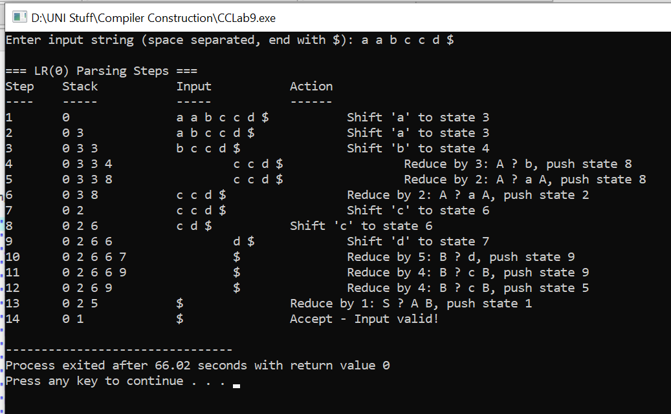
Output:

Task No # 02
SLR Parser:

Grammar for SLR:

S → A B
A → a A | b
B → c B | d

Solution:

First Sets:

FIRST(A) = {a, b}
FIRST(B) = {c, d}
FIRST(S) = FIRST(A) = {a, b}

Follow Sets:
FOLLOW(S') = {$}
FOLLOW(S) = {$}
FOLLOW(A) = {c, d}
FOLLOW(B) = {$}

SLR Action/Goto table

State | a | b | c | d | $ | S | A | B
0 | s3 | s4 |  |  |  | 1 | 2
1 |  |  |  |  | acc
2 |  |  | s6 | s7 |  |  |  | 5
3 | s3 | s4 |  |  |  |  | 8
4 |  |  | r3 | r3
5 |  |  |  |  | r1
6 |  |  | s6 | s7 |  |  |  | 9
7 |  |  |  |  | r5
8 |  |  | r2 | r2
9 |  |  |  |  | r4

Code:

#include <iostream>
#include <stack>
#include <vector>
#include <map>
#include <string>
using namespace std;

int main() {
map<int, map<string, string>> action;
action[0]["a"] = "s3";
action[0]["b"] = "s4";
action[1]["$"] = "acc";
action[2]["c"] = "s6";
action[2]["d"] = "s7";
action[3]["a"] = "s3";
action[3]["b"] = "s4";
action[4]["c"] = "r3";
action[4]["d"] = "r3";
action[5]["$"] = "r1";
action[6]["c"] = "s6";
action[6]["d"] = "s7";
action[7]["$"] = "r5";
action[8]["c"] = "r2";
action[8]["d"] = "r2";
action[9]["$"] = "r4";

// GOTO Table
map<int, map<string, int>> goTo;
goTo[0]["S"] = 1;
goTo[0]["A"] = 2;
goTo[2]["B"] = 5;
goTo[3]["A"] = 8;
goTo[6]["B"] = 9;

// Production
struct Production {
string lhs;
int rhsLen;
string rhs;
};
map<int, Production> productions;
productions[1] = {"S", 2, "A B"};
productions[2] = {"A", 2, "a A"};
productions[3] = {"A", 1, "b"};
productions[4] = {"B", 2, "c B"};
productions[5] = {"B", 1, "d"};

vector<string> input;
string symbol;

cout << "Enter input string (space separated, end with $): ";
cout << "\nExample: a b c d $\n\n";
while (cin >> symbol) {
input.push_back(symbol);
if (symbol == "$") break;
}

stack<int> st;
st.push(0);
int i = 0;

cout << "\n SLR Parsing Steps \n";
cout << "Step\tStack\t\tInput\t\tAction\n";

int step = 1;

while (true) {
int state = st.top();
string curr = input[i];

// Display stack
stack<int> temp = st;
vector<int> stackVals;
while (!temp.empty()) {
stackVals.push_back(temp.top());
temp.pop();
}
cout << step++ << "\t";
for (int j = stackVals.size() - 1; j >= 0; j--) {
cout << stackVals[j];
if (j > 0) cout << ",";
}
cout << "\t\t";
for (size_t j = i; j < input.size(); j++) {
cout << input[j];
if (j < input.size() - 1) cout << " ";
}
cout << "\t\t";
if (action[state].find(curr) == action[state].end()) {
cout << "Error: No action defined for state " << state
<< " on symbol '" << curr << "'\n";
break;
}

string act = action[state][curr];

if (act == "") {
cout << "Error: Invalid action\n";
break;
}

if (act[0] == 's') {
int nextState = stoi(act.substr(1));
st.push(nextState);
cout << "Shift '" << curr << "' ? state " << nextState << "\n";
i++;
}
else if (act[0] == 'r') {
int prodNo = stoi(act.substr(1));
int len = productions[prodNo].rhsLen;
string lhs = productions[prodNo].lhs;
string rhs = productions[prodNo].rhs;
for (int j = 0; j < len; j++) {
st.pop();
}
int topState = st.top();
int gotoState = goTo[topState][lhs];
st.push(gotoState);

cout << "Reduce: " << lhs << " ? " << rhs;
cout << " (pop " << len << ", push state " << gotoState << ")\n";
}
else if (act == "acc") {
cout << "Accept ?\n";
cout << "\n*** Input string is valid according to the grammar ***\n";
break;
}
}
return 0;
}

Output:

